Granting the access to the role

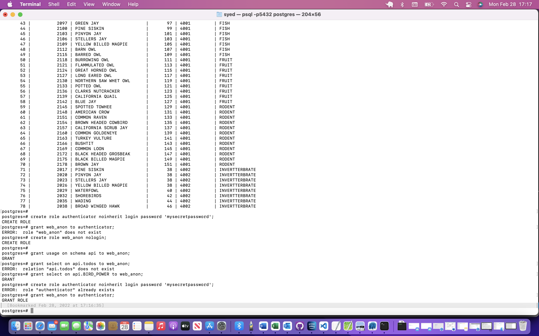

Api.bird_power data

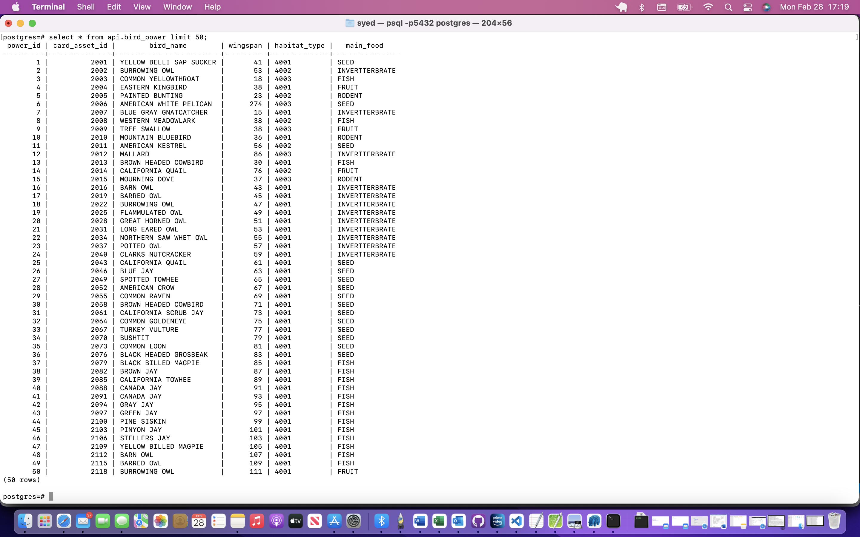

Running the api call after killing existing process

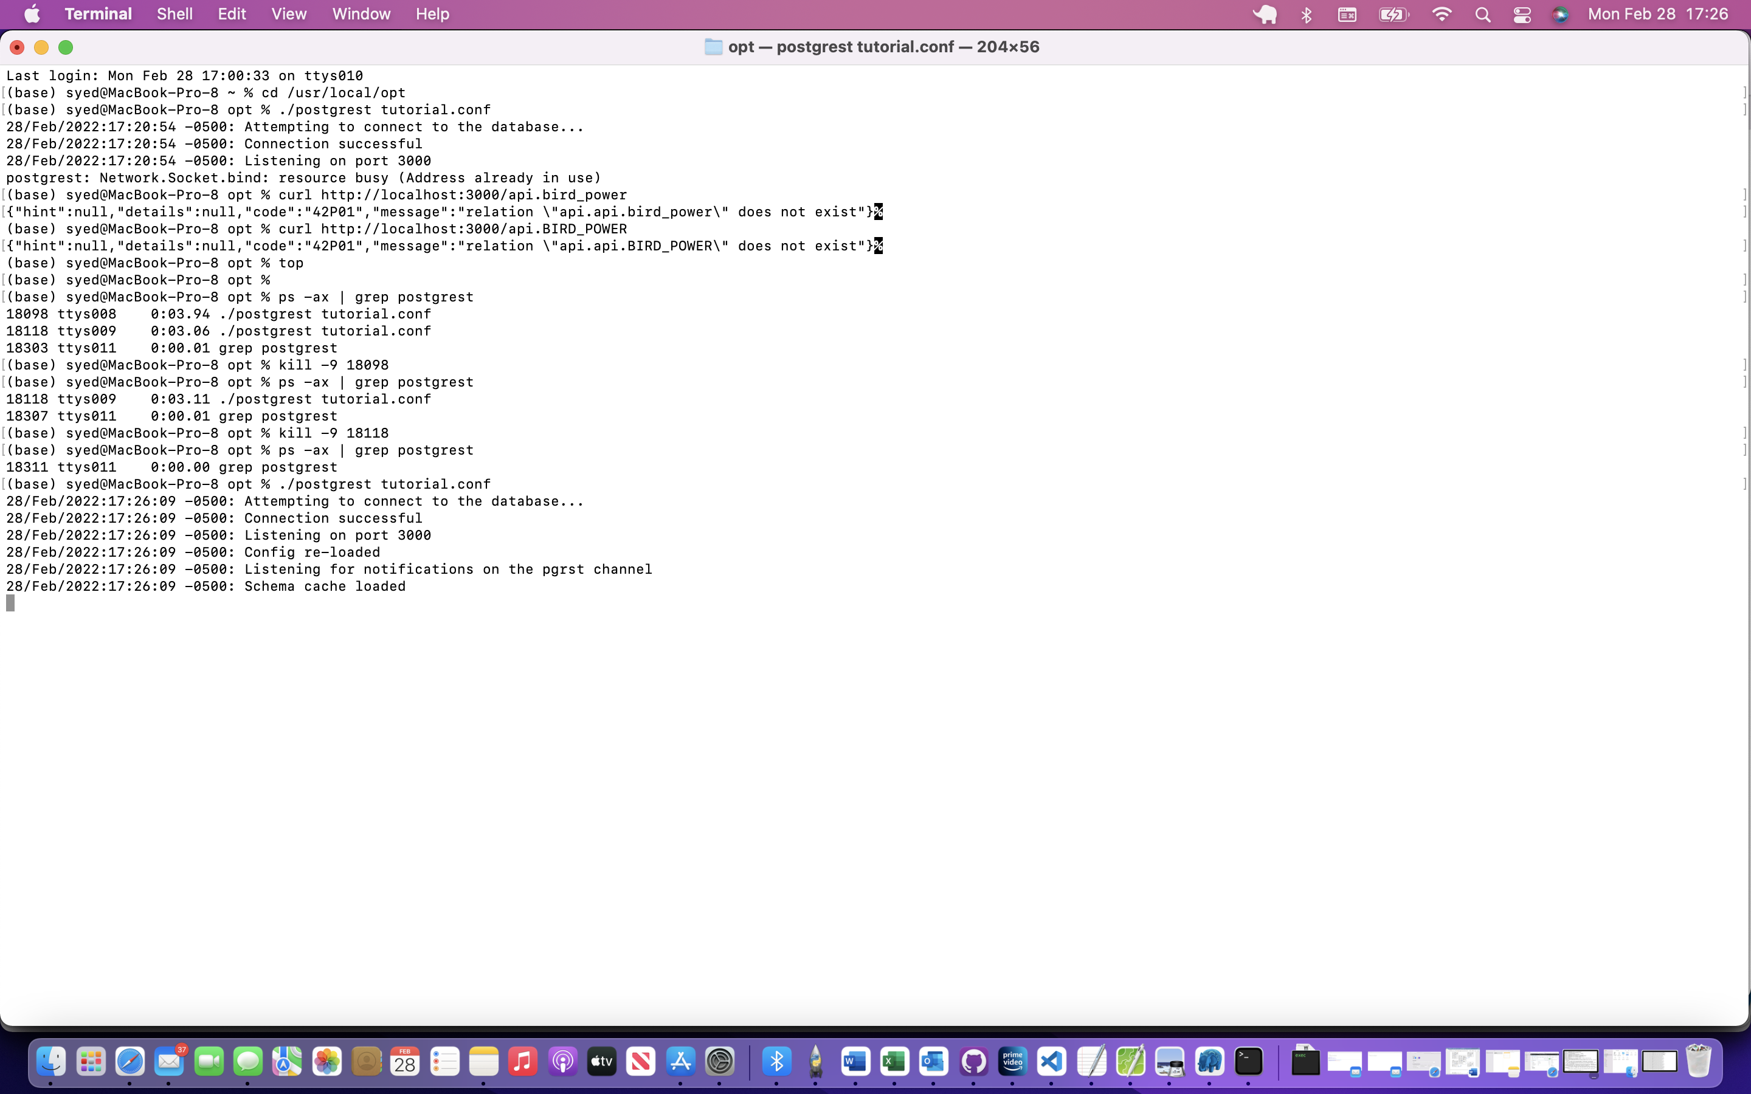

Opening another terminal to listen it

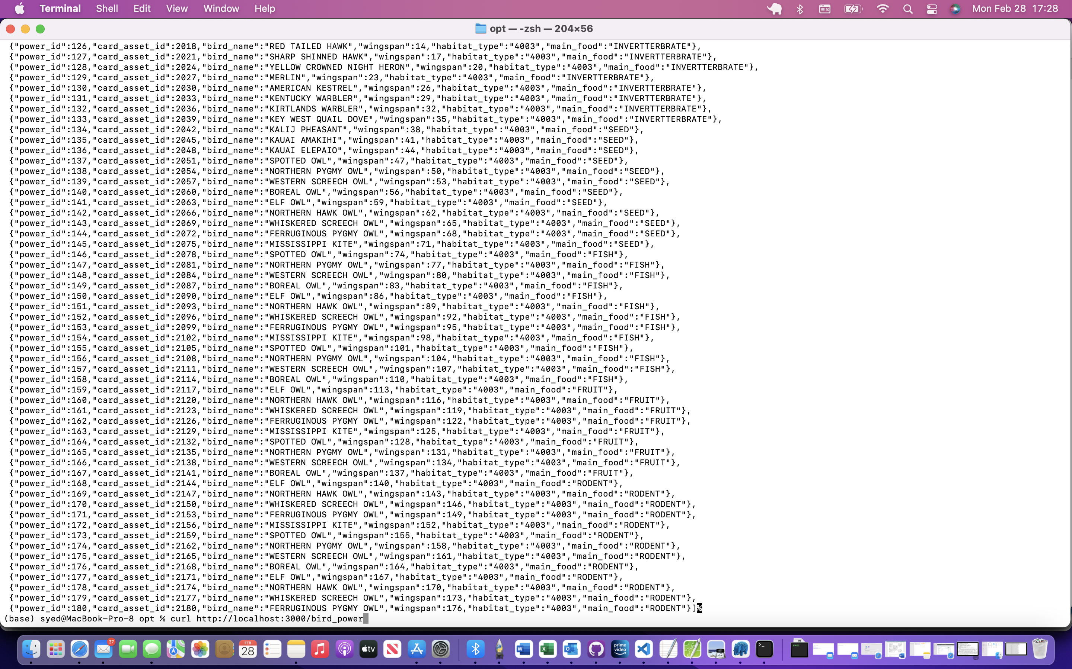

Now taking RODENT food type birds

curl <http://localhost:3000/bird_power> | grep “RODENT”

